AOC I-Menu
User Manual



DOCUMENT REFERENCE FRAME
Version : 1.0.0
Status : Release
Classification : Confidential
Date : 30/07/26

1 Revision History
Date | Revision | Editor | Description
2021-05-19 | 1.0 | Mandy | Release
2021-10-12 | 2.0 | Mandy | 1.Delete Red /Blue/Green Chromaticity、White point（5.5）  2.Move screen rotate to picture column（5.1）
2021-10-25 | 2.1 | Mandy | Add functions:  - Run At Startup(5.5)  - Resolution(5.1)  - Gamma(5.1)  - Eco mode(5.1)  - OverDrive(5.1)  - Clean Vision(5.1)  - DCR(5.1)  - Low blue mode(5.2)  - DCB mode(5.2)  - Volume(5.5)
2022-01-20 | 2.2 | Mandy | Add :  - Screen+ (5.4)  2.Dynamic zooms (5.4)
2022-03-23 | 2.3 | Mandy | 1.Add functions:  1) Input  2) HDR Mode  3) Timed shutdown  2.Adjust sRGB and User Define to the options under Color temperature
Table 1 – I-Menu Revision History

CatalogueTOC \o "1-3" \h \u
1 Revision History 2
2 Windows Installation 1
3 Open Methods 3
4 Software Update 4
5 Home 4
5.1 Picture 6
5.2 Color 8
5.3 Language 11
5.4 Screen+ 12
5.5 Settings 14
5.5 Tray 16

2 Windows Installation
1. Download the AOC G-Menu executable, and double click the EXE file to start the installation.
2. Accept the license agreement by selecting the I Agree button.
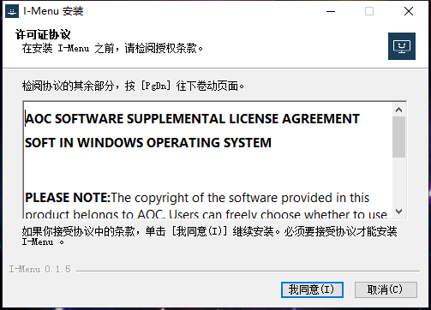
3. Select the installation folder. Selecting the Browse button will open a Browse for Folder dialog box.
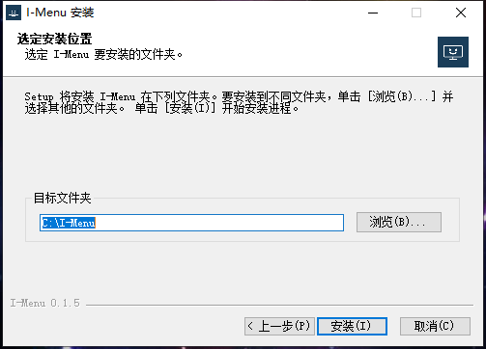
- Confirm Installation by pressing the Install button.
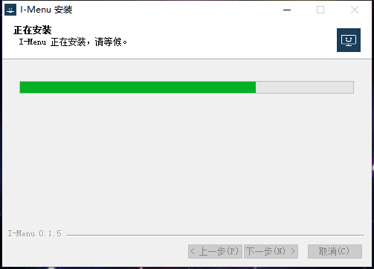
5. Complete the installation by pressing the Done button. Congratulations on installing I-menu!
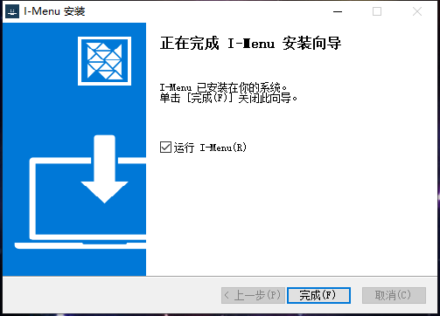

3 Open Methods
There are 3 ways to access the I-Menu application.
① Start Menu> I-Menu
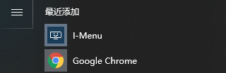

Figure 2-Touchpoint Start Menu
② Taskbar>Right click on the taskbar icon
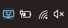
Figure 3-Touchpoint Task Tray
③ Shortcut on Desktop
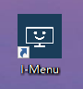
Figure 4-Touchpoint Short Cut on Desktop

4 Software Update
- When you enter the I-Menu home page, the software will automatically check for updates, if there is a new version, it will be downloaded in the background.
- After the download is complete, the interface will alert you to install the update.
- Note: If there is no network connection, I-Menu will not be able to detect updates.

5 Home
- Open I-Menu application and enter the home page.
Minimize
Close
Navigation

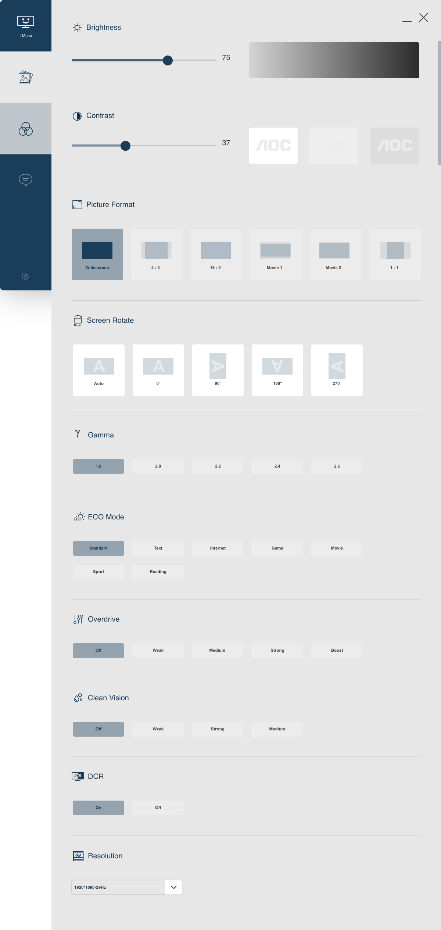

Figure 5-Homepage
1）Close—— Click the Close button to close the application interface, the actual application is still running in the background.
2）Minimize/Restore——Click to switch the interface to zoom in/restore the display.
3）Navigation：Picture/Color/Language/Screen+/Settings

5.1 Picture
Figure 6- Picture
- Brightness
- Slider 0-100, default 50
- Adjust the output of the backlight to reduce eyestrain.
- Contrast--Slider
- Slider 0-100, default 50
- Adjust the contrast ratio between the luminance of the brightest white and darkest black.
3）Picture Format
- Screen format selection in different proportions.
- The first option is selected by default.
4）Screen Rotate--Radio option
- 5 options:auto, 0°,90°,180°,270°
- Auto by default
5）Gamma--Radio option
- The gamma level adjusts pixel luminance at each brightness level. Lower gamma increases brightness making shadows look brighter and can result in a flatter, washed out image with brighter highlights. Higher gamma reduces brightness making it more difficult to see details in shadows.
6）ECO Mode
- Options：Standard, Text, Internet, Game, Movie, Sport, Reading
- Standard by default
7）Overdrive--Single option
- Options：Off, Weak, Medium, Strong,Boost
- Off by defalut
8）Clean Vision
- Options：Off, Weak, Medium, Strong,Boost
- Off by defalut
9）DCR--- Toggle
- Dynamic Contrast Ratio enables the monitor to adjust dynamic range according to the brightest and darkest pixels currently displayed.
- Default is Off.
10）Resolution
- The resolution can be set through the application
- The "Resolution" drop-down list will display all supported resolutions in the EDID report and in the "Display Properties"
- Selecting other resolutions will be applied automatically

5.2 Color
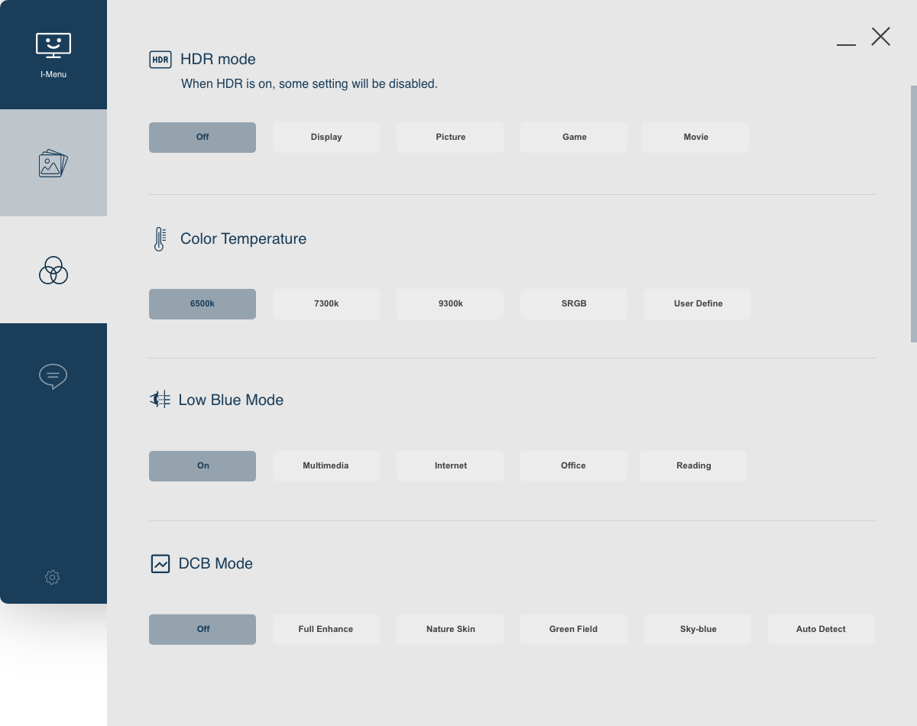
Figure 7- Color
- HDR Mode
- The options are Off, Picture, Movie, Game. Displayed according to the actual device.
- When HDR is on, some setting will be disabled.

2) Color temperature
- Color temperature is a way to describe the light appearance provided by a light bulb.
- The first option is selected by default
sRGB
- It is mutually exclusive with the color temperature option above and cannot be selected at the same time
User Define
- Three sliders of red, green and blue
- Slider 0-100, default 50
- Slider to increase/decrease the color value
  - Reset--Button
- Click to restore the User Define to factory settings
  - Undo
- Return to the original settings state
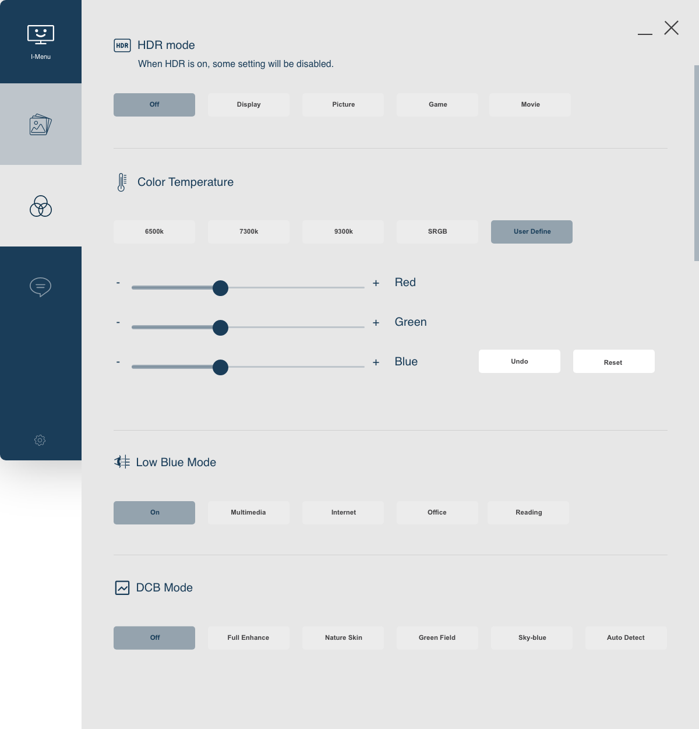
3）Low blue Mode
- Off
  - Turns Off Low Blue Mode, no filtering of blue light.
- Multimedia
  - Turns on Low Blue Multimedia Mode, increased filtering of blue light.
- Internet
  - Turns on Low Blue Internet Mode
- Office
  - Turns on Low Blue Office Mode
- Reading
  - Turns on Low Blue Reading Mode, maximum filtering of blue light.
- Off by default
4）DCB Mode
- Dynamic Color Boost enhances specific colors in the palette. Nature Skin enhances skin tone colors, Green Field enhances greens like grass, and Sky-blue enhances blues like the sky.
- Selection for Off, Full Enhance, Nature Skin, Green Field, Sky-blue, Auto Detect.
- Off by default.

5.3 Language
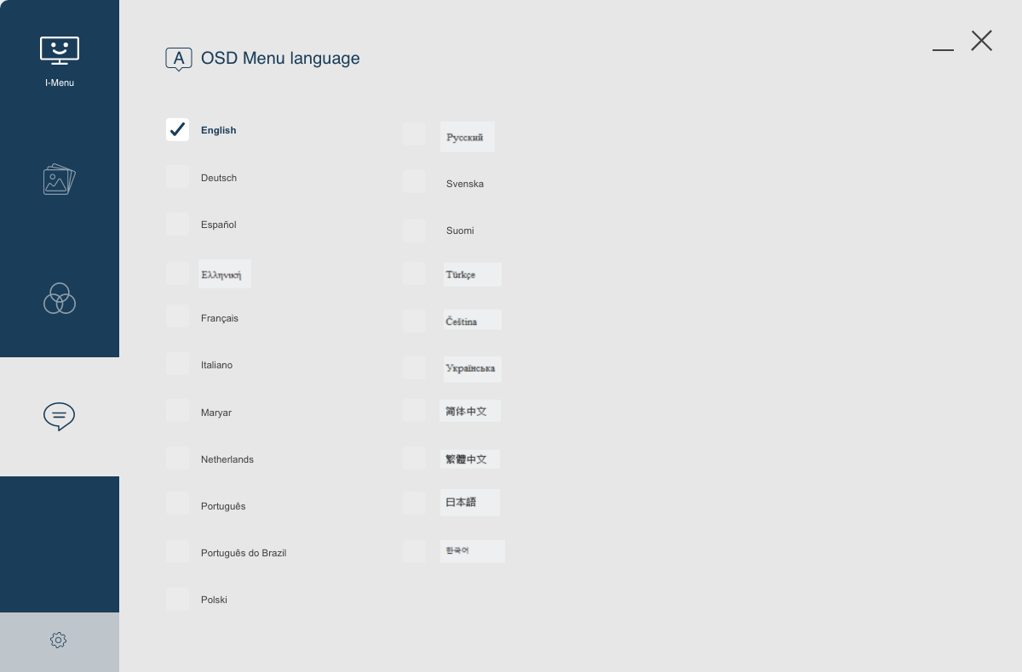
Figure 8-language
- OSD Menu Language
- English by default
- Click the appropriate language button to switch OSD Menu languages immediately.

5.4 Screen+
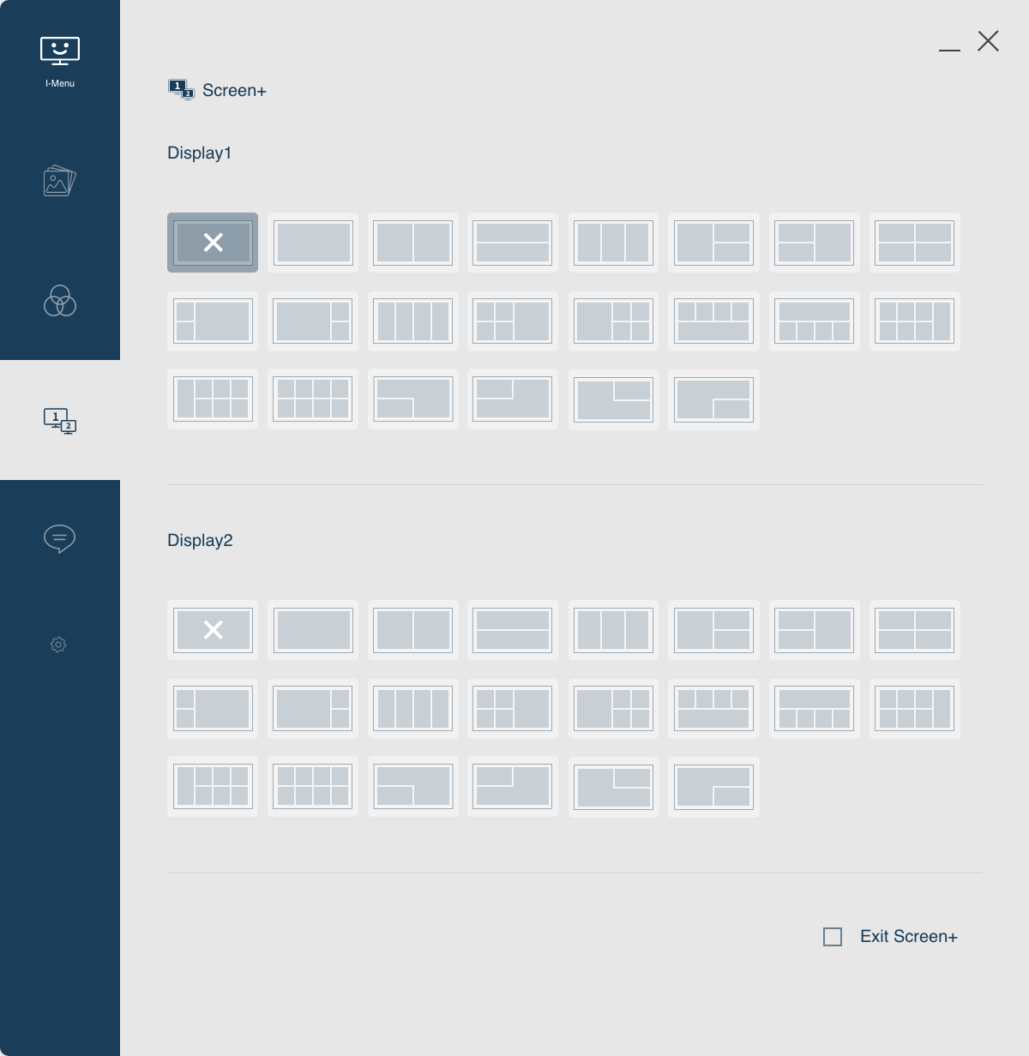
- This function is supported by the third application in the software
- A total of 22 split screen styles are supported
- When there are multiple monitors, they are displayed separately, and the split screen settings can be performed separately.
- Exit Screen+
  - When checked, exit the screen+ application
- Dynamic zooms
  - shift + alt + G Start dragging
  - shift + alt + E Exit drag function
  - shift + alt + R Reset the current zoom
  - shift + alt + A Reset all the zooms

5.5 Settings
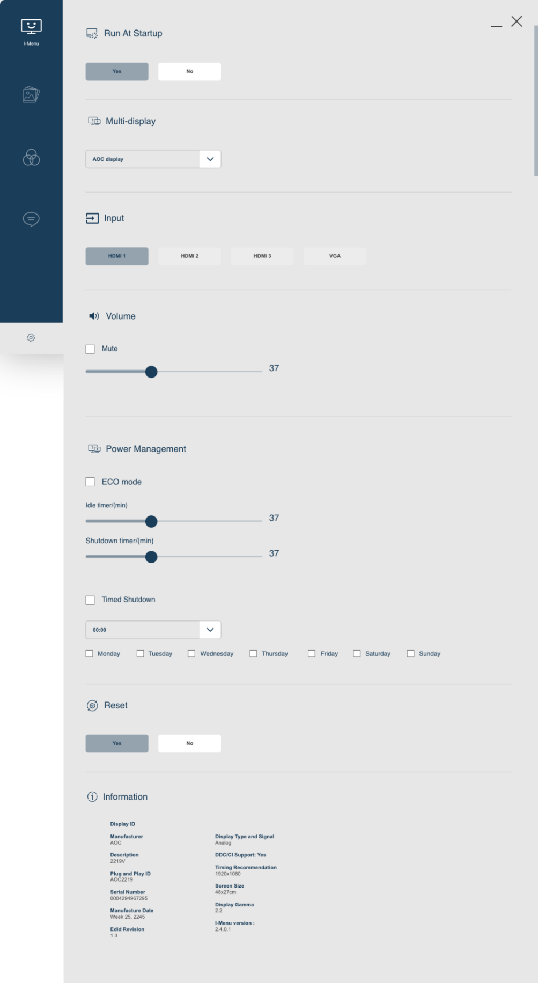
Figure 9-Settings
- Run At Startup--Single option
- When turned on, the I-menu will be automatically launched every time the device is turned on and displayed in the tray
- Yes by default
2）Multi Display
- The default display is the target device currently set
- Click the drop-down box to display all currently connected displays
- Switch to another display,all settings will be updated accordingly
- Volume--Slider
- Adjust Volume Slider 0 (off) – 100 (maximum). Default is 0.
- Mute --check box
  - Enabled: Turns off sound, greys out volume slider.
  - Disabled: Turns on sound, and enables volume slider.The volume is restored to the state before muting.
- Input
- Display the input supported by the monitor
- Selecting another input will switch to the newly selected input
- Power Management
a. Power saving mode
- Enable - Enable power saving mode.
- Disable - Disable power saving mode.
- Idle Timer
- Control how long the screen is idle before it goes into sleep mode.
- Power Timer
- The power timer controls when the display turns off. You can turn the display back on using the power button on the edge of the display hardware.
b.Schedule daily power off
- Enable - enable timed shutdown.
- Disable - disable timer shutdown.
- Choose when to power off the monitor.
- Set the shutdown time.
- Set the date of timed shutdown, you can choose more than one.

6）Reset--Single option
Click the [Yes] button, the I-menu settings will be reset and restored to the default state.
7）Information--Text
- Information items include:
- Display ID
- Manufacturer
- Description
- Plug and Play ID
- Serial Number
- Manufacturer Date
- Edid Revison
- Display Type and Signal
- DDC/CI Support
- Timing Recommendation
- Screen Size
- Display Gamma
- I-Menu version

5.5 Tray
In the tray, user can make basic Settings for the system, such as Language and Rescan.
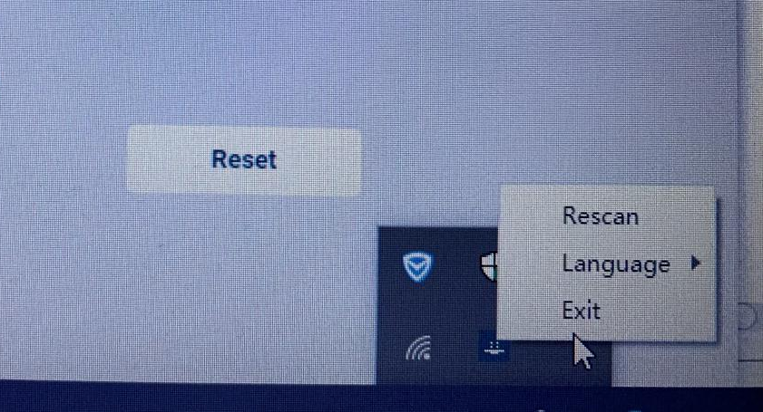
Figure 12- Tray-Menu
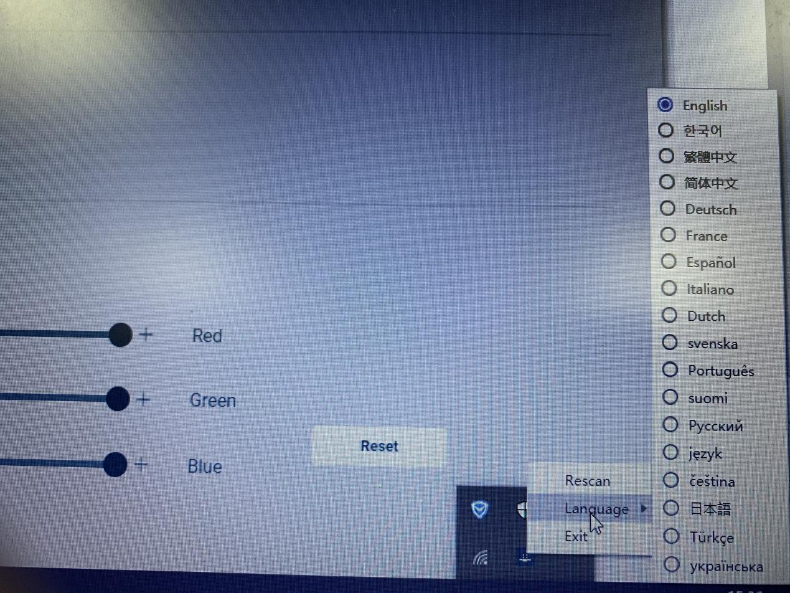
Figure 13- Tray-Language
- Rescan
- Click to reloads the software information.
- Language
- Click to change the software language.
- Exit
- Click to exit software.

